2020 Board Members:
Pat Baird, President
Jeff Baird, Treasurer
Ione Fejfar,
Secretary/Newsletter
Marty Mahrt, Member
Larry Zimmerman, Member

Inside This Issue:
2020 – The 10th Season That Wasn’t
Thanks For All The Help!
Also Thankful . . .

REMINDER: Giving Tuesday, a SD day of giving is Dec. 1, 2020.

2020 --- THE
SEASON THAT WASN’T

Well, what can be said about 2020? It was definitely a year of change, challenge, confusion, isolation and fear. With almost all of our weeks filled, the Board decided to suspend all hosting operations this summer and we began notifying the families. Some were sad, some were disappointed, but almost all were relieved as they, too, were hesitant to risk their family’s health and wellbeing. And so we had no families this summer.

And they were greatly missed. The sponsoring business owners, the business employees, the Board members and the many volunteers who interact with our families during their week here in Custer, all felt the void in their absence and voiced on many occasions how deprived they felt not being able to provide our much-needed healing opportunity. It was a heavyhearted time for all.
The only silver lining, if there is one to be found, is that all families scheduled for their week in 2020 will now be rescheduled for 2021. At this time, we are hopeful that 2021 will be a year of new beginnings, new health and prosperity for all. We continue to receive and process new applications from combat injured veterans in hopes we can accommodate them all in the years to come.
With this crazy year upon us, it leads me to reflect on the past and our accomplishments. Here is a quick review I’d like to share:

November, 2020
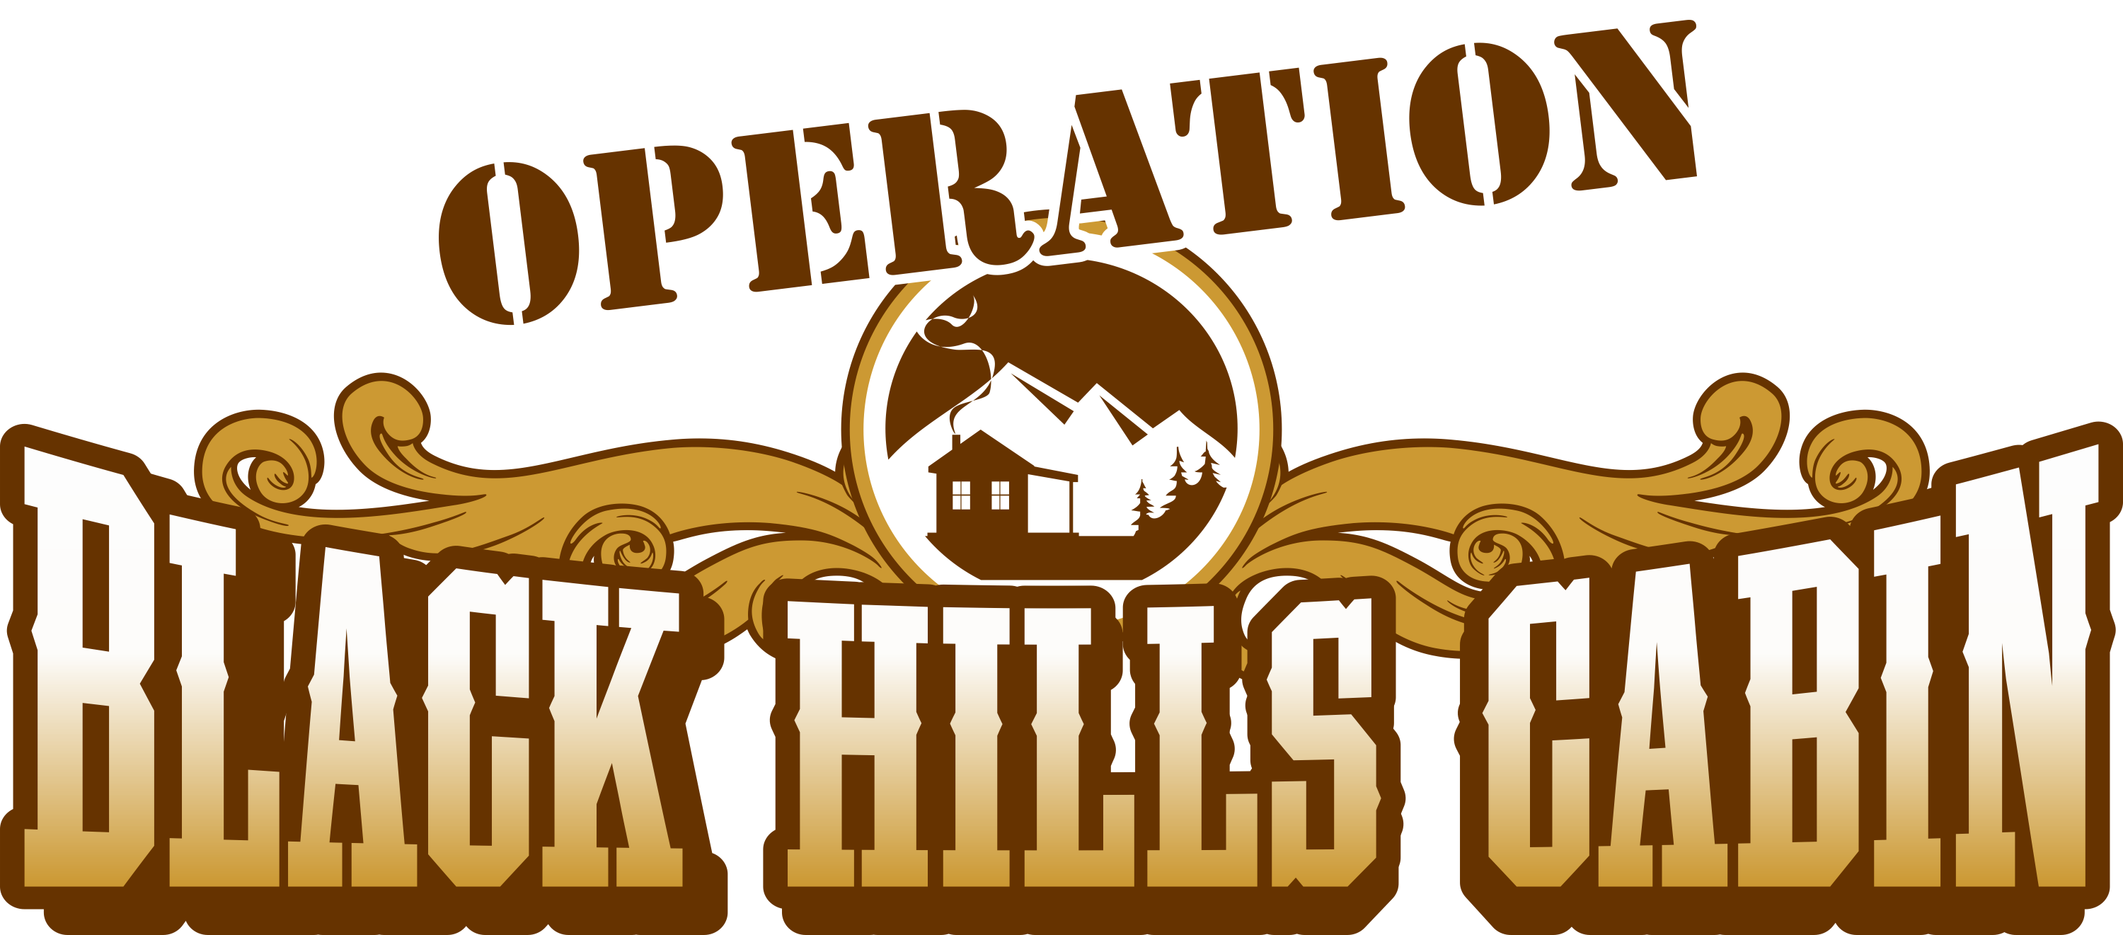
Page 2 of 4

CABIN CLIPS

November,202020 20201920192019
Page 2 of 2

2011 - Just getting started and organized. 3 families hosted.
2012 – In search of our own cabin. 4 families hosted.
2013 – Our very own cabin is delivered! 11 families hosted.
2014 – Made our first documentary film, “The New Normal”; hosted a fly fishing
tournament fundraiser; developed The Healing Hike; 18 families hosted.
2015 – First family from South Dakota arrives; “Community of the Year” awarded;
first transportation reimbursement grant received; 16 families hosted.
2016 – Began reimbursing transportation costs; Tribute To The Troops awareness
event held. 13 families hosted.
2017 – Adopted a last-minute list for previously hosted families to utilize cabin
for a no-frills week due to late cancellations. 14 families hosted.
2018 – New rack card published; more transportation reimbursement grants
received. 18 families hosted.
2019 – American Heroes Outdoors filmed; Eye On Keloland segment aired. 17
families hosted.
2020 – The season that wasn’t.
114 families hosted from 34 different states.
THANKS FOR ALL THE HELP!
I forgot to mention 2020 was also a year of HAIL in Custer. Because of the generous showing of support, OBHC now has its second new roof, new gutters and downspouts (still coming) and a fresh new coat of stain. It looks like an actress walking down the red carpet at an award show!! What a great job occomplished by a fine group of volunteers.

ALSO THANKFUL . . .
- To Billy Gibson on behalf of the SD Rural Electric Association who filmed and interviewed at the cabin. Great exposure! View on You Tube: https://youtu.be/6G7n7Dt0wbg.
- To SD Daughters of the American Revolution for choosing OBHC as their project and their very generous donation.
- To the Black Hills Area Community Foundation, Southern Hills By Choice for
their support and grants.
- To all those who donated their Thrivent Choice Dollars!
- To the Disabled American Veterans Northern Hills, Chapter 11 for their generous donation.
- To the Custer branch of BH Federal Credit Union for their yearly raffle proceeds.
- To the City of Custer for choosing OBHC as recipient of the Mayor’s Ride proceeds.
- To all the other donors and organizations that put their faith in OBHC and have continued to support us in 2020.

Our thoughts and prayers are with all combat wounded veterans and families out there as well as anyone affected by any of the calamities of 2020 including sickness, fires, hurricanes, etc. Let’s all pray for a better year in 2021!

